Molecular Dynamics Calculations in NAMD

dr Karina Kubiak – Ossowska
High Performance Computing Support Team
Department of Physics

e-mail: karina.kubiak@strath.ac.uk

- Introduction
NAMD (Fig.1), is a parallel molecular dynamics code designed for high-performance simulation of large biomolecular systems. Based on Charm++ parallel objects NAMD scales to hundreds of processors on high-end parallel platforms and tens of processors on commodity clusters using gigabit ethernet. NAMD uses the popular molecular graphics program VMD for simulation setup and trajectory analysis, but is also file-compatible with AMBER, CHARMM, and X-PLOR. NAMD is distributed free of charge with source code. Detailed description of NAMD may be found at http://www.ks.uiuc.edu/Research/namd/. The detailed guide and tutorial for NAMD may be downloaded from http://www.ks.uiuc.edu/Research/namd/2.7/ug/ and http://www.ks.uiuc.edu/Training/Tutorials/namd/namd-tutorial-win.pdf, respectively. The instruction below does not explain all details, it gives you a simple guide how to run basic simulations (protein in water box) instead.
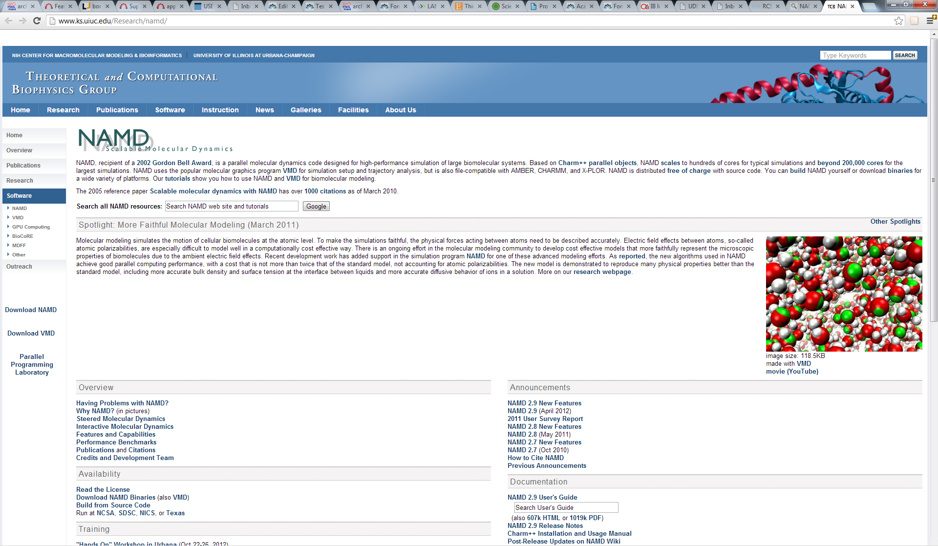

Fig. 1. NAMD Web page

- Standard simulations

Check the computer system, ensure all programs are installed. If you are working on ARCHIE-WeSt all example files can be found at the directory: /users/cwb08102/NAMD_Training

Check what modules are loaded by typing:
module list

check what modules are available to load by typing:
module avail

load the module by typing:
module load /apps/bin/vmd/1.9.1
module load /mpi/gcc/openmpi/1.4.5
module load /libs/gcc/fftw2/float-mpi/2.1.5
module load /apps/gcc/namd/mpi/2.8

1. Protein structure
To simulate the protein first we need a x,y,z coordinates of each atom in the protein. Such information is deposited in the PDB (protein data bank) which consist a X-ray as well as NMR protein structures. Because of technical reasons, for big proteins only X-ray structures are available. The main difference between NMR and X-ray structure is that in the first one hydrogen atoms are included while there are no hydrogen atoms in X-ray structure (H atoms are too light to X-ray diffraction experiments). Usually we are interested in big proteins that is why calculations using the X-ray structure as a starting one are descried.

- download the correct structure
Go to PDB (http://www.rcsb.org/pdb/home/home.do), and look for protein structure you are interested in (Fig.2). Let’s say that you are looking for hen egg white lysozyme (HEWL). If you already know the PDB ID (1iee) you can type it in the first text window. Usually you don’t know the ID, so give the protein name (e.g. hen egg white lysozyme) in the second text window and click search. You will see a lot of records. There is more than one structure deposited in PDB. Look for the protein obtained with the highest resolution, without ligands and protein engineering procedures. We need the native structure. Check the year when the structure was published, read carefully records provided about structure details and download the original paper describing the structure published (Fig. 3). Once you are sure it is the right structure, download it to your computer in the pdb format (Fig. 3). Let’s call this file protein_original.pdb.

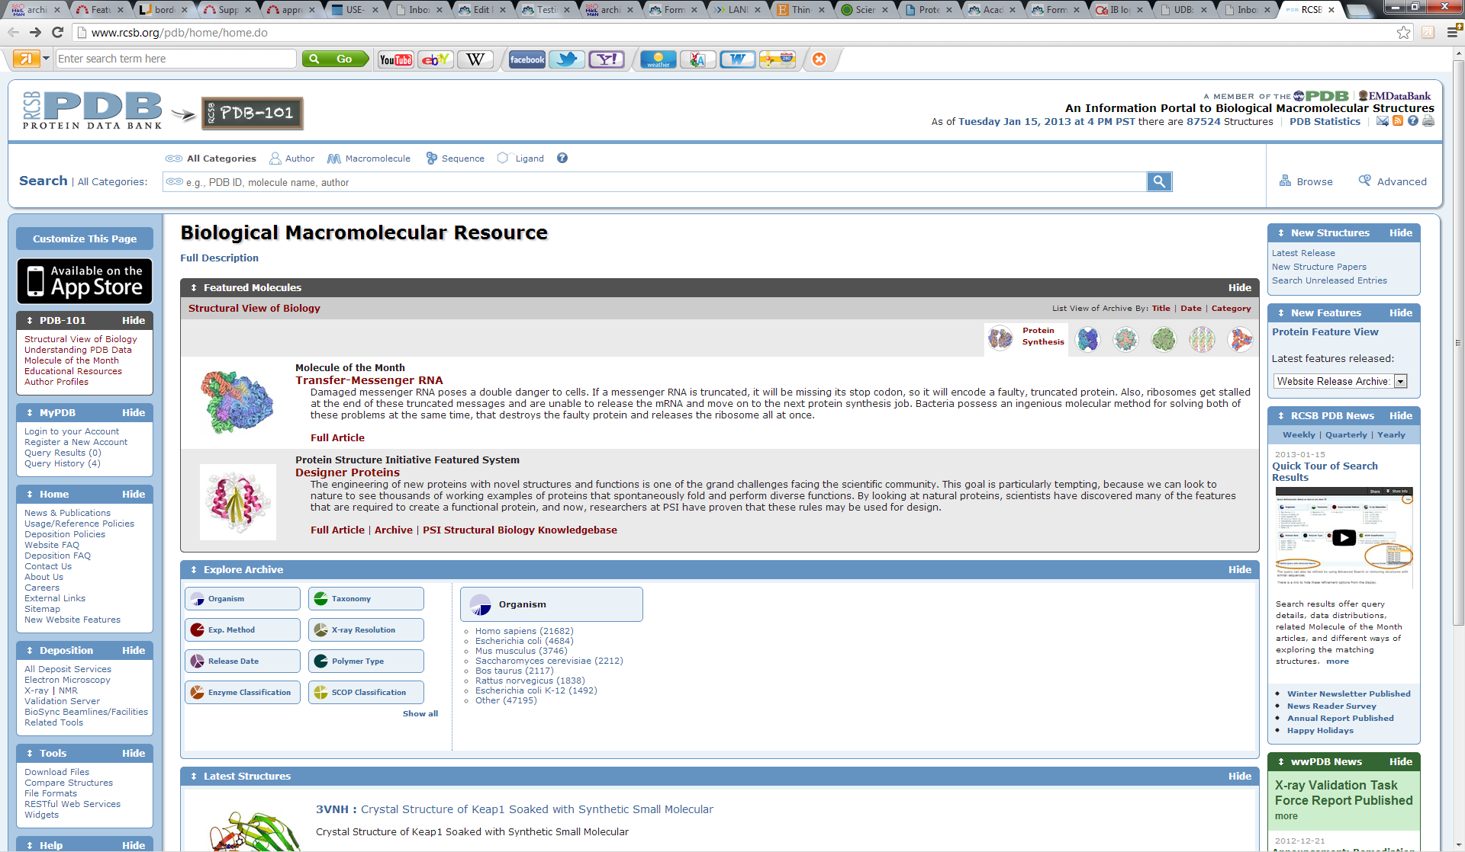

Fig.2. Protein Data Bank (pdb) starting page

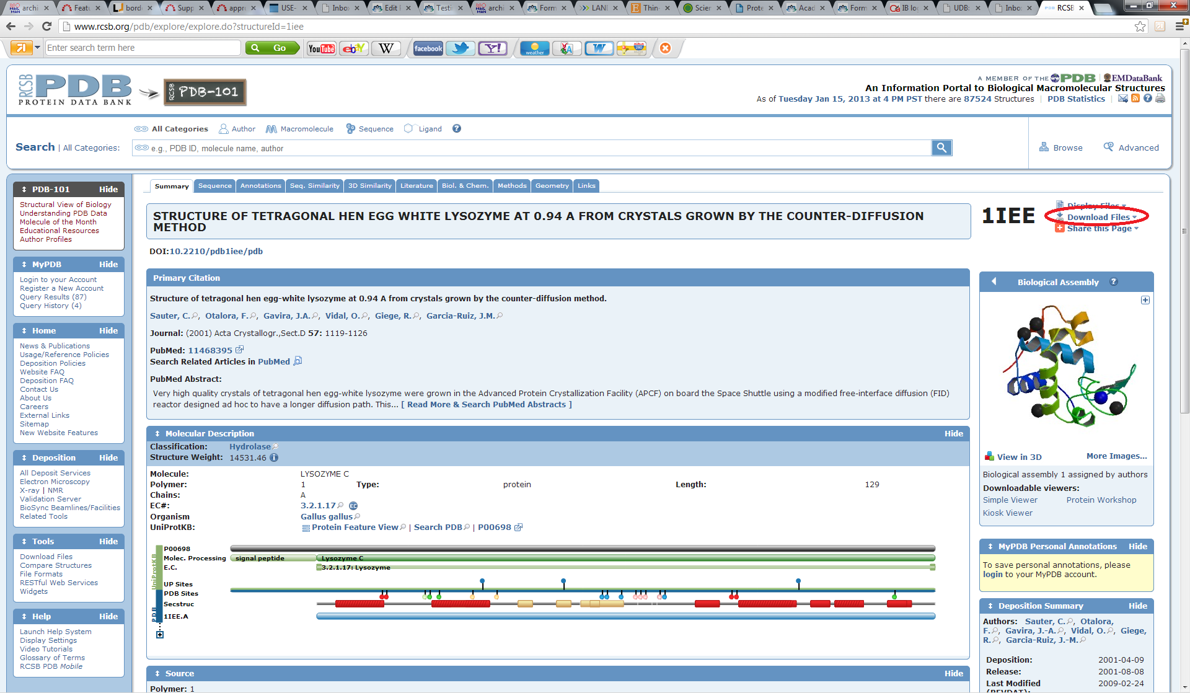

Fig. 3. PDB – searching result and Download the structure

- See the protein
Open the vmd program and then go to Main menu → File → New molecule → protein_original.pdb. The other way to see the protein is type in your terminal commend line vmd protein_original.pdb, the result will be exactly the same. Now play in VMD, rotate the protein, change the representation (Main menu → Graphics → Representations), see the protein structure. Read the VMD tutorial to learn how to visualize and present the protein, how to change colors, how to highlight only a chosen residue etc.

2. Prepare the simulations
The *.psf file together with *.pdb contain all information about our protein. The *.pdb file consist only initial coordinates of atoms, the *.psf file consist all other information (bond length, angles, force constants, charges, van der Waals parameters etc.). The psf file is created basing on the *.pdb file and the top_all27_prot_na.inp (the topology file). Since it is possible to change the topology file by adding new parameters it is better to use the file top_all27_prot_surf.inp created by myself.

- Prepare the pdb file
Open the protein_original.pdb file using a vi or any other editor. Read the file, check if there are missing residues, where should be disulphide bonds (SSBOND) etc. Note that everything which is not a protein is called HETATM (hetero atom). First we need to have all segments (water, protein, ions) in a separate files. Copy the protein_original.pdb file with the name: only_protein.pdb (eg. we assume that we do not need water and ions coming from the pdb, if we would we will have to add more segments in psfgen.inp file) and delete everything what is not a protein.

- Create a psfgen.inp file
We need to create a psfgen_HEWL.inp file:
psfgen << ENDMOL

topology top_all27_prot_surf_na.inp

alias residue HIS HSD
alias atom ILE CD1 CD
alias residue HOH TIP3
alias atom HOH O OH2
alias residue NA SOD
alias residue CL CLA

segment PRO {
pdb only_protein.pdb
}

patch DISU PRO:6 PRO:127
patch DISU PRO:30 PRO:115
patch DISU PRO:64 PRO:80
patch DISU PRO:76 PRO:94

coordpdb only_protein.pdb PRO

writepsf only_HEWL.psf

guesscoord

writepdb only_HEWL.pdb

ENDMOL

Then type in the command line type:
./psfgen_HEWL.inp > log

to run the psfgen module. To see details read the log file (note that psfgen_HEWL.inp should be an executable file).

In the psfgen_HEWL.inp file lines starting from “alias” are used to change names, in the pdb the histidine residue is called HIS, while NAMD uses HSD. Similarly the atom CD1 in ILE (isoleucine residue) in NAMD is called as CD, water is not HOH but TIP3 and oxygen in water molecule is not O (as in pdb) but OH2. Moreover, sodium and chlorine atoms are called SOD and CLA in NAMD.

The lines starting from a word “patch” are creating a disulphide bonds between chosen cysteines: CYS6-CYS127, CYS30-CYS115, CYS64-CYS80 and CYS76-CYS94. Note that only residue number is given. The “patch DISU PRO:6 PRO:127” means that we want to connect protein (PRO) residue number 6 with protein residue number 127. Using VMD (or by reading the protein_oryginal.pdb file using any text editor) we can check what those residues are cysteines. Note that not all proteins have disulphide bridges – that is why it is very important to read the information coming from the PDB. If disulphide bridges are not required simply delete lines starting with the word “patch”.

Word “guesscoord” means that we want to guess coordinates of any missing atoms. So the program will guess coordinates of all missing hydrogens in the protein structure and water as well. Moreover, sometimes even a heavier atoms then hydrogen are missing in the pdb structure, the program will guess all of them. How does NAMD know which atoms should be guessed and where to put them? The information is in the top_all27_prot_surf_na.inp and only_protein.pdb files. In the second one there is a list of residues, atoms and positions, the residue is compared with the library (top file) and something is missing, the program automatically adds the missing atoms using a geometrical information stated in the top file.

As the result of typing
./psfgen.inp > log
Three files are created: only_HEWL.psf, only_HEWL.pdb and the log file. Open them using any text editor (for example vi, kwriter or joe) to see how they look like and what information are they consist. Please note that in the log file you can see something like:

…
Warning: poorly guessed coordinates for 26 atoms (10 non-hydrogen):
Warning: poorly guessed coordinate for atom HT1 LYS:1 PRO
Warning: poorly guessed coordinate for atom HT2 LYS:1 PRO
Warning: poorly guessed coordinate for atom HT3 LYS:1 PRO
Warning: poorly guessed coordinate for atom HG LEU:8 PRO
Warning: poorly guessed coordinate for atom HG LEU:17 PRO
Warning: poorly guessed coordinate for atom HG LEU:25 PRO
Warning: poorly guessed coordinate for atom HG LEU:56 PRO
Warning: poorly guessed coordinate for atom HG2 PRO:70 PRO
Warning: poorly guessed coordinate for atom HG LEU:75 PRO
Warning: poorly guessed coordinate for atom HG LEU:83 PRO
Warning: poorly guessed coordinate for atom HG LEU:84 PRO
Warning: poorly guessed coordinate for atom OT1 LEU:129 PRO
Warning: poorly guessed coordinate for atom OT1 LEU:129 PRO
Warning: poorly guessed coordinate for atom OT1 LEU:129 PRO
…

This warning only means that the guessed positions of above atoms probably are not perfect. MAND will manage that later, at the minimization step.

View your files in VMD by typing

vmd only_HEWL.pdb only_HEWL.psf

(or type in the command line vmd, then go to Main menu → File → New molecule → open → only_HEWL.pdb
highlight only_HEWL.pdb, right click and chose Load data into molecule → only_HEWL.psf)

Note that your files contain only the protein, there is no water, surface, counter ions. To add counter ions first you have to solvate the protein.

- Solvation
Now we need to add water to the system, we can do it under VMD. By the default the protein is solvated using TIP3P water model.

Open your files in the VMD by typing vmd only_HEWL.pdb only_HEWL.psf and go to Main menu → Tk Console. To solvate type:
:

% solvate only_HEWL.psf only_HEWL.pdb +x 22 -x 22 +y 27 -y 28 +z 20 -z 8 -o only_HEWL_S

(in the example –t 9 option is used – see below)

The new, solvated structure will appear. Numbers +x 22, -x22, +y 27 etc. are the space in Å (10⁻¹⁰ m) between the protein and the end of the water box. You can change this numbers. Nevertheless, the surface used for HEWL was lying in the (x,y) plane and extend the protein by 22Å in +x and -x direction and by 27Å and 28Å in the +y and -y directions, respectively. The initial distance between the protein and the surface was 8Å and the end of the primary cell for HEWL on surface was 20Å away from the protein in the z direction. So the water box used top add ions was about the same as the water box used in the adsorption simulations. If you have different protein or different surface first check the distances in all directions.

Note: If you are going to simulate the protein only in water you can use any margin, the best choice is to use the same margin in each direction and not smaller than 9Å (at least three water molecules between the protein and the end of the water box). To do this you can type -t 9 instead of typing distances in the each direction (e.g. type: % solvate only_HEWL.psf only_HEWL.pdb –t 9 -o only_HEWL_S). We will use this structure for next steps.

Note: Check carefully your final, solvated structure. This preparation step, together with adding ions is crucial in the following simulations. If your D0 or D1 simulation fails sometimes is necessary to come back to the solvation stage and change the parameters used.

Do not leave VMD – now you should add ions.
- Add counter ions
Now we need to neutralize the protein by adding counter ions. We can do it under VMD but it is not possible to neutralize the system without water. So select new molecule in the main menu (highlight in yellow) and then add ions. Go to Main menu → Extensions → Modeling → Add Ions. The new window will open. Check if as an input files your solvated files are given (only_HEWL_S.psf and only_HEWL_S.pdb). Give an output prefix, for example HEWL_002M_S and give the concentration of ions in mol/L, for example type 0.02, select neutralize and set NaCl concentration to 0.02mol/l, check if the Segment ID is ION and then click Autoionize button. (Fig. 4). Scroll up VMD Tkconsole and check protein charge before adding ions, how many atoms were added and what is the current charge of the system. If you will try to ionize the structure without water VMD will show the error and it will close (because the volume is unknown). Check (visually) where ions are placed

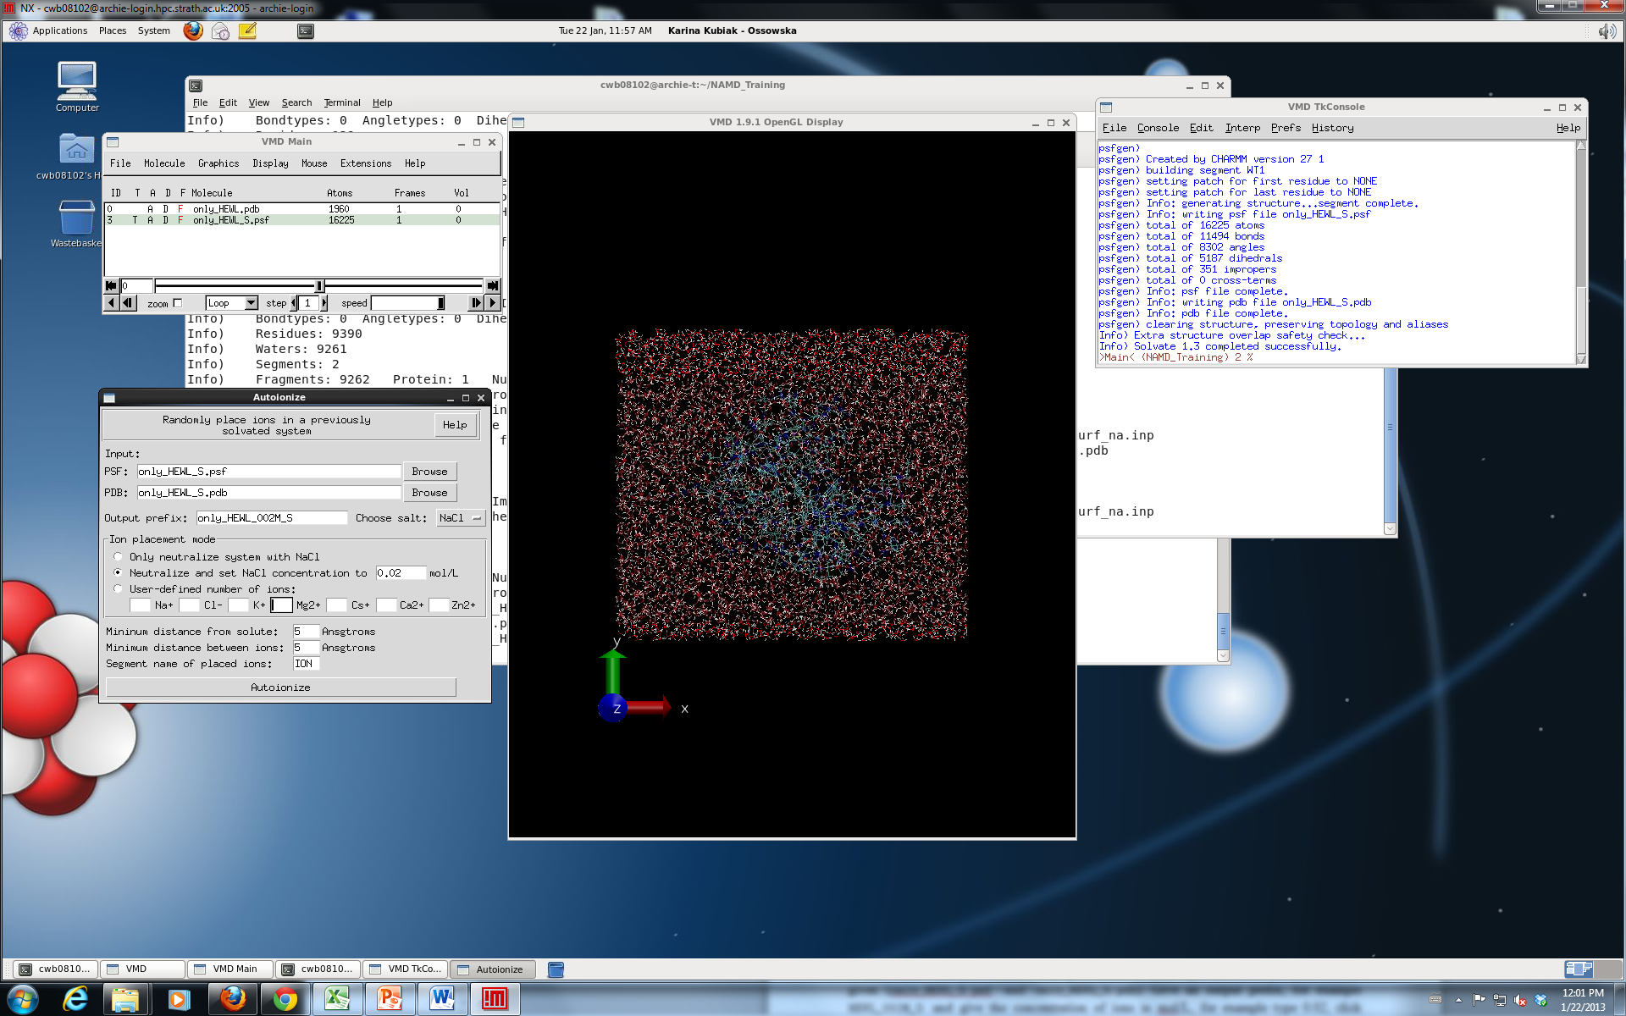

Fig. 4. Adding ions under vmd.

To run protein simulation in water only (+ buffer of course) you shall use your two new files: HEWL_002M_S.pdb and HEWL_002M_S.psf as they are and run simulation D0 (water equilibration). First you have to center and fix the protein (using ctrbox.tcl, and fix.tcl, see below).

- Center and Fix the protein
Now we need to center your water box and find atoms which has to be fixed in the D0 simulation (n only water minimization). To do that you need two scripts written by myself: ctrbox.tcl and fix_protein.tcl. Go to to Main Menu → Extensions → TK Console and in the Tk console type:

% play ctrbox.tcl
% ctrbox HEWL_002M_S.psf HEWL_002M_S.pdb HEWL_002M_SC

New files HEWL_002M_SC.pdb and HEWL_002M_SC.psf will appear. At the end of HEWL_002M_SC.pdb file the dimensions of the primary cell are given (open the file using vi to see them). Leave the vmd and open again using the most recent structures:

vmd HEWL_002M_SC.pdb HEWL_002M_SC.psf

Go to to Main Menu → extensions → TK Console and in the Tk console type:
% play fix_protein.tcl

The new file fix_protein.pdb is created. Do not forget to change the name to HEWL_002M_FIX.pdb.

Now we can start the simulation.

3. Run the Simulations
The proper simulation contains three main steps: (i) water equilibration (D0 dynamics), (ii) heating of the system (D1 dynamics) and (iii) the simulation (D2 and further). The water equilibration step is necessary to get a proper water model in which water positions are random, not generated via program (note that before equilibration your water is well ordered what is not natural.

- Water minimization and equilibration
Typical input to the water equilibration step (file HEWL_002M_D0.inp):
structure HEWL_002M_SC.psf
coordinates HEWL_002M_SC.pdb

paratypecharmm on #it is possible to use GROMACS or AMBER FF
parameters par_all27_prot_surf_na.inp #parameters file
exclude scaled1-4
1-4scaling 1.0

switching on
switchdist 8
cutoff 12
pairlistdist 14
margin 4 #ideally the margin should be 0, sometimes
stepspercycle 20 #you need to increase that

wrapWater on
rigidBonds water #water is treated as a rigid body
# to reduce number of calculations
timestep 1.0 #in femto seconds

outputenergies 100
outputtiming 100
binaryoutput yes
outputname HEWL_002M_D0 #output files name
dcdfreq 100

temperature 300 #temperature in Kelvins

langevin on #using Langevin dynamics
langevinDamping 5
langevinTemp 300
langevinHydrogen no

useFlexibleCell yes #the water box can be flexible to keep the
useGroupPressure yes # constant pressure

LangevinPiston on #Langevin piston method to keep (scale)
LangevinPistonTarget 1.01325 #temperatures is used
LangevinPistonPeriod 200
LangevinPistonDecay 100
LangevinPistonTemp 300

cellBasisVector1 59.43600082397461 0.0 0.0 #primary cell
cellBasisVector2 0.0 52.60499572753906 0.0 # vector taken
cellBasisVector3 0.0 0.0 58.24599838256836 #from *SC.pd
cellOrigin 0.0 0.0 0.0

fixedAtoms on
fixedAtomsFile HEWL_002M_FIX.pdb #atoms which cannot move: - protein
fixedAtomsCol O

minimize 1000 #water minimization for 1000 steps
run 100000 #heating water only for 100 ps

In the above example, when margin was 0, in the output file (HEWL_002M_D0.out ) the error has appeared:

…
WRITING COORDINATES TO DCD FILE AT STEP 20700
The last position output (seq=20700) takes 0.001 seconds, 308.133 MB of memory in use
TIMING: 20800 CPU: 67.2482, 0.00324654/step Wall: 67.2482, 0.00324654/step, 0.0723257 hours remaining, 308.132812 MB of memory in use.
ENERGY: 20800 0.0000 0.0000 0.0000 0.0000 -58172.7614 5297.1181 0.0000 0.0000 8448.0484 -44427.5948 298.7737 -52875.6432 -44424.0259 297.2008 72.7791 73.6412 155428.6534 -58.2830 -58.3755

WRITING COORDINATES TO DCD FILE AT STEP 20800
The last position output (seq=20800) takes 0.001 seconds, 308.133 MB of memory in use
FATAL ERROR: Periodic cell has become too small for original patch grid!
Possible solutions are to restart from a recent checkpoint,
increase margin, or disable useFlexibleCell for liquid simulation.
FATAL ERROR: Periodic cell has become too small for original patch grid!
…
…

Calculations have stopped, the margin was increased to 2, then to 4 and finally the D0 stage was competed. Try to not increase margin more than it is required. The other option is restart the calculation without increasing the margin, and repeat that as long as the trajectory will be fine. It is not guaranteed when it will happen.

If the calculations are correct, five new files should be created: HEWL_002M_D0.out (you can call it the log file, HEWL_002M_D0.vel, HEWL_002M_D0.xsc, HEWL_002M_D0.coor, HEWL_002M_D0.dcd

File type | contents | Format
out | The log file. Contains energies, temperature, pressure etc in each frame. | Text
vel | Final velocities | Binary
xsc | Final cell dimensions | Binary
coor | Final coordinates | Binary
dcd | Trajectory | Binary

The end of the correct output file should look like follows:

HEWL_002M_D0.out
WRITING COORDINATES TO DCD FILE AT STEP 101000
The last position output (seq=101000) takes 0.001 seconds, 308.012 MB of memory in use
TIMING: 101000 CPU: 325.262, 0.0034132/step Wall: 325.262, 0.0034132/step, 0 hours remaining, 308.011719 MB of memory in use.
ETITLE: TS BOND ANGLE DIHED IMPRP ELECT VDW BOUNDARY MISC KINETIC TOTAL TEMP POTENTIAL TOTAL3 TEMPAVG PRESSURE GPRESSURE VOLUME PRESSAVG GPRESSAVG

ENERGY: 101000 0.0000 0.0000 0.0000 0.0000 -58042.8008 5127.2276 0.0000 0.0000 8339.4205 -44576.1526 294.9320 -52915.5731 -44570.9090 295.3623 -257.6267 -246.7263 155248.3516 -66.3426 -66.6349

WRITING EXTENDED SYSTEM TO OUTPUT FILE AT STEP 101000
WRITING COORDINATES TO OUTPUT FILE AT STEP 101000
CLOSING COORDINATE DCD FILE
The last position output (seq=-2) takes 0.016 seconds, 309.918 MB of memory in use
WRITING VELOCITIES TO OUTPUT FILE AT STEP 101000
The last velocity output (seq=-2) takes 0.002 seconds, 309.129 MB of memory in use
====================================================

WallClock: 326.861908 CPUTime: 326.861908 Memory: 309.128906 MB
End of program

Explanation of other parameters used can be found in NAMD tutorial. Note that the protein is frozen, while water and ions not. See that four files have been produced: HEWL_002M_D0.out, HEWL_002M_D0.dcd, HEWL_002M_D0.coor and HEWL_002M_D0.xsc. The first one contains the information about running the program, energies reached in each time, temperatures etc. The second one is the trajectory file (coordinates of atoms in the each time step), the third one contains coordinates of atoms in the last time step and the fourth one contains data describing parameters for periodic boundary conditions (PBC). Now you can watch your trajectory in vmd. Type in the commend line

vmd HEWL_002M_SC.pdb HEWL_002M_SC.psf
Go to Main Menu → Load data into trajectory → HEWL_surf_002M_D0.dcd

Trajectory is not very exciting, since only water molecules are moving. Note that during first two steps they are moving quite slowly (the minimization stage) and then they suddenly start to move faster and faster (the heating stage).

- heating of the system
Now we need to heat the whole system to required temperature, let’s say 300K. We will start from 0K, then we will take random initial velocities and heat the system.

Typical input to the whole system heating step (file HEWL_002M_D1.inp):
structure HEWL_002M_SC.psf
coordinates HEWL_002M_SC.pdb
bincoordinates HEWL_002M_D0.coor #the last structure from the
# water equilibration stage
paratypecharmm on
parameters par_all27_prot_surf_na.inp
exclude scaled1-4
1-4scaling 1.0

switching on
switchdist 8
cutoff 12
pairlistdist 14
margin 0
stepspercycle 20

wrapWater on
warpAll on #nothing will disappear from the primary simulation cell
rigidBonds water

timestep 1.0

outputenergies 100 #how frequently the information is written
outputtiming 100 #to the *.out file
binaryoutput yes
outputname HEWL_002M_D1
dcdfreq 100 #how frequently the dcd file is written

temperature 0 #initial temperature

reassignFreq 1000 #how frequently the temperature will be increased
reassignIncr 10 #what is the increment
reassignHold 300 #task temperature

extendedSystem HEWL_002M_D0.xsc

minimize 10000 #number of minimization steps of the whole system
run 300000 #total simulation time (heating + equilibration)

Note that at this stage you are using the coordinates produced in the water equilibration. Once is finished watch the *.D1.dcd file and note that a *D1.vel file containing velocities of each atom at the last time stem was created. In the above example we will minimize protein, water and ions for 10,000 steps, then we will heat the system from 0K to 300K by increasing the temperature by 10K every 1000 steps, It means that we will heat for 30 x 1000steps =30000steps=30ps and then we will run the simulation in the constant temperature (equilibrations) 300K for 300ps-30ps=270ps.

c) The production simulation

Now you can run the production simulation, only trajectories D2 (and further) are usually analyzed in details, nevertheless always have a look on D0 and D1 trajectories to be sure that the preparation stage was fine.

The typical input for the production simulation (file HEWL_002M_D2.inp):

structure HEWL_002M_SC.psf
coordinates HEWL_002M_SC.pdb
bincoordinates HEWL_002M_D1.coor

paratypecharmm on
parameters par_all27_prot_surf_na.inp
exclude scaled1-4
1-4scaling 1.0

switching on
switchdist 8
cutoff 12
pairlistdist 14
margin 0
stepspercycle 20

wrapWater on
wrapAll on
rigidBonds water

timestep 2.0 #note that 2fs time step is used

outputenergies 100
outputtiming 100
binaryoutput yes
outputname HEWL_002M_D2
dcdfreq 200
restartfreq 100000
restartname rest_HEWL_002M_D2 #how frequently the restart files
#will be saved
binvelocities HEWL_002M_D1.vel #in previous stages we haven’t
#used the velocity file – for D0
#we haven’t such file, in D1 the
#initial temperature was 0K so
#atoms haven’t velocities.

langevin on
langevinDamping 5
langevinTemp 300
langevinHydrogen no

extendedSystem HEWL_002M_D1.xsc

run 5000000

Note: now 2fs time step is used. It is not always safe, it can be used only for a stable system (ensure that the system is stable before using 2fs time step!). Bigger timestep will produce longer trajectoryin the same wall-clock time, but the simulation can be unstable. When using 2fs in principle the SHAKE algorithm should be used for all hydrogens, not only for water hydrogens. Using bigger time step can cause an “explosion” of your system. 1fs is usually saver but … slower ☹

If you want to run next 10 ns copy the above input file and change names D1 → D2 and D2 → D3.

Enjoy your simulations!

Note: in our example on ARCHIE the job length is 500,000 steps = 1ns (not 10ns as in the above input).

4. How to launch the job

If you want to run the simulation on the HPC you need one extra file to submit your job. The sample job script for ARCHIE-WeSt (HEWL_D0.sh):

#

export PROCS_ON_EACH_NODE=12

# ************* SGE qsub options ****************
#Export env variables and keep current working directory
#$ -V -cwd
#$ -P training.prj
#Select parallel environment and number of parallel queue slots (nodes)
#$ -pe mpi-verbose 10
#Combine STDOUT/STDERR
#$ -j y
#Specify output file
#$ -o out.$JOB_ID
#Request resource reservation (reserve slots on each scheduler run until enough have been gathered to run the job
#$ -R y
#Request exclusivity of each node
# ************** END SGE qsub options ************

export NCORES=`expr $PROCS_ON_EACH_NODE \* $NSLOTS`

export OMPI_MCA_btl=openib,self

# Execute NAMD2 with configuration script with output to log file
charmrun +p$NCORES -v namd2 HEWL_002M_D0.inp > HEWL_002M_D0.out

It will run your job on 120 cores (10 nodes with 12 cores each). Up to 120 cores NAMD scales almost linear (9.8 speedup) on ARCHIE. To submit the job type:

qsub HEWL_D0.sh

to check the status type:

qstat

To check the calculation progress see the output file (HEWL_002M_D0.out)

To run trajectories D0, D1 and D2 one after other the end of the above use HEWL_D0_D2.sh script:
…
# Execute NAMD2 with configuration script with output to log file
charmrun +p$NCORES -v namd2 HEWL_002M_D0.inp > HEWL_002M_D0.out
charmrun +p$NCORES -v namd2 HEWL_002M_D1.inp > HEWL_002M_D1.out
charmrun +p$NCORES -v namd2 HEWL_002M_D2.inp > HEWL_002M_D2.out

6. How to analyze the trajectory

- visual analysis
- calculate rmsd and rmsf using the tcl script provided (root mean square distance and fluctuations of particular residues, respectively)
- measure distances during the trajectories (for details see vmd tutorial)
- write your own tcl scripts

- Advanced Simulations

1. PME
To see how to use Particle Mesh Ewald method for calculating electrostatic interactions in our case study see files: HEWL_002M_PME_D0.inp, HEWL_002M_PME_D0.inp and HEWL_002M_PME_D0.inp. Lines like follow have appeared:

PME yes
PMEGridsizex 60
PMEGridsizey 53
PMEGridsizez 59

Note the numbers given should be not smaller than basic cell vectors (cellBasisVector). The PME grid size should be a number which can be produced by adding or multiplying (or both) numbers 2, 3 and 5. In our case cellBasisVector1 was 59.43600082397461, so we need to produce number ~60 (3x5x2x2=60), cellBasisVector2 was 52.60499572753906 (2x3x2x2x2+5=53), cellBasisVector3 was 58.24599838256836 (3x3x2x3+5=59)

2. SMD

a) Constant velocity pulling
In this case again we need a SMD file, wich should be created basing on the original *SC*pdb file. Again we will pull only one atom CZ from residue ARG128

cp HEWL_002M_SC.pdb HEWL_002M_SMD.pdb

HEWL_002M_SMD.pdb:
…
ATOM 1930 NE ARG P 128 -17.843 -1.453 -18.235 0.00 0.00 PRO N
ATOM 1931 HE ARG P 128 -18.195 -1.709 -19.143 0.00 0.00 PRO H
ATOM 1932 CZ ARG P 128 -18.593 -1.453 -17.171 1.00 0.00 PRO C
ATOM 1933 NH1 ARG P 128 -18.147 -1.043 -15.996 0.00 0.00 PRO N
ATOM 1934 HH11 ARG P 128 -18.730 -1.076 -15.196 0.00 0.00 PRO H
…

In this file change the occupancy values for all normal atoms to 0.00. The occupancy value 1.00 indicates the SMD atom.

HEWL_002M_D2_v0005Aps.inp:
structure HEWL_002M_SC.psf
coordinates HEWL_002M_SC.pdb
bincoordinates HEWL_002M_PME_D1.coor

paratypecharmm on
parameters par_all27_prot_surf_na.inp
exclude scaled1-4
1-4scaling 1.0

switching on
switchdist 8
cutoff 12
pairlistdist 14
margin 0
stepspercycle 20

wrapWater on
wrapAll on
rigidBonds water

timestep 2.0

outputenergies 100
outputtiming 100
binaryoutput yes
outputname HEWL_002M_D2_v0005Aps
dcdfreq 200
restartfreq 100000
restartname rest_HEWL_002M_D2_v0005Aps
binvelocities HEWL_002M_PME_D1.vel

SMD on
SMDFile HEWL_002M_SMD.pdb
SMDk 4
SMDVel 0.00001
SMDDir 0.0 0.0 1.0
SMDOutputFreq 100

langevin on
langevinDamping 5
langevinTemp 300
langevinHydrogen no

extendedSystem HEWL_002M_PME_D1.xsc

run 5000000

In this case the pulling velocity has to be specified in the input file – parameter SMDVel. Value 1x10⁻⁵ indicates that the pulling velocity is 10⁻⁵ A/step. The step is 2fs, so the velocity is 5x10⁻³ A/ps. The total trajectory length is 10ns, so the atom should move by 50 A during the trajectory. SMDk specifies the spring constant, from my experience 4 is the best value. Sample output:

HEWL_002M_PME_D2_v0005Aps.out
…
WRITING COORDINATES TO DCD FILE AT STEP 499800
The last position output (seq=499800) takes 0.001 seconds, 309.785 MB of memory in use
TIMING: 499800 CPU: 2004.69, 0.0042082/step Wall: 2004.69, 0.0042082/step, 0.000233789 hours remaining, 309.785156 MB of memory in use.
ENERGY: 499800 813.0956 1119.8652 641.3451 66.5502 -58379.7599 4427.1856 0.0000 0.0000 10249.3769 -41062.3413 300.0943 -51311.7182 -40987.6851 299.7518 343.5534 311.7697 158153.2920 350.8725 349.1137
# Timestep Atom Coordinates force
SMD 499900 -10.7265 -1.48513 -11.9009 -0 0 -75.3415
TIMING: 499900 CPU: 2005.09, 0.00398227/step Wall: 2005.09, 0.00398227/step, 0.000110619 hours remaining, 309.785156 MB of memory in use.
ENERGY: 499900 790.4483 1107.3516 645.1351 63.4061 -58390.6894 4438.7077 0.0000 0.0000 10272.2767 -41073.3640 300.7648 -51345.6407 -40992.6688 300.4989 291.3132 310.8214 158153.2920 335.7182 338.0513
…

b) Constant force pulling
In this example we will use the results from the adsorption trajectory. It means that initially the HEWL protein was placed in the system containing the mica surface model and 90ns trajectory was calculated. During that trajectory the protein adsorbed onto the surface (adsorption trajectory) and the last stage is treated as a starting structure for constant force pulling trajectory (desorption trajectory). It means that the structure after 90ns of adsorption trajectory was saved (under vmd) then water, surface and ions were again added and the system was centered. It means that files: O1_90ns_002M_v0_SC.psf and O1_90ns_002M_v0_SC.pdb were obtained. Then the trajectory D0 was ran to minimize the water. Therefore we have files O1_90ns_002M_v0_D0.coor, O1_90ns_002M_v0_D0.xsc, O1_90ns_002M_v0_D0.vel and O1_90ns_002M_v0_D0.dcd (two last files are not needed for the SMD simulation). Note – the preparation stages are not included in the example.

In general we can address the problem that we have: O1_90ns_002M_v0_SC.psf, O1_90ns_002M_v0_SC.pdb, O1_90ns_002M_v0_D0.coor and O1_90ns_002M_v0_D0.xsc files and we want to run SMD trajectory with constant force pulling. First we have to create the pdb file which will contain information about pulled atoms (the constant force file or SMD file). Copy your *SC*pdb file with other name:

cp O1_90ns_002M_v0_SC.pdb O1_90ns_002M_v0_force_f800pN.pdb

The new file requires some changes. Let’s assume we want to pull ARG128 CZ atom in the z direction with the force 800pN (11.54 kcal/mol). The most interesting part of the O1_90ns_002M_v0_force_f800pN.pdb file:

O1_90ns_002M_v0_force_f800pN.pdb
…
ATOM 1929 HD2 ARG A 128 21.098 -6.897 -27.912 0.00 0.00 BIA H
ATOM 1930 NE ARG A 128 20.244 -8.259 -29.183 0.00 0.00 BIA N
ATOM 1931 HE ARG A 128 20.153 -9.222 -28.935 0.00 0.00 BIA H
ATOM 1932 CZ ARG A 128 0.000 0.000 1.000 11.54 1.00 BIA C
ATOM 1933 NH1 ARG A 128 21.059 -7.038 -30.984 0.00 0.00 BIA N
ATOM 1934 HH11 ARG A 128 21.195 -7.096 -32.010 0.00 0.00 BIA H
ATOM 1935 HH12 ARG A 128 20.604 -6.238 -30.648 0.00 0.00 BIA H
ATOM 1936 NH2 ARG A 128 21.276 -9.260 -30.989 0.00 0.00 BIA N
…

In this file the information which atom (atoms) has to be pulled, what is the force value and direction is stored. The last column (B column, green circle) value is equal 0.00 for all normal atoms. Value 1.00 indicates that the force will be applied to the atom. The occupancy column (orange circle) value is 0.00 for all normal atoms. In the case of SMD atom it specifies the force value (in kcal/mol, 1kcal/mol=69.479pN). The (x,y,z) columns (blue circle) stores x,y,z coordinates of normal atoms and (x₁,y₁,z₁) coordinates of the force vector in the case of SMD atom. (x₀,y₀,z₀) coordinates of the force vector are = and (x,y,z) coordinates of the SMD atom (stored in O1_90ns_002M_v0_SC.pdb file, as coordinates of all other atoms). The program will read only rows with B value 1.00 and will omit all rows with B value 0.00.

The SMD sample input to the production trajectory D2:

HEWL_002M_PME_D2_f100pN.inp:
structure O1_90ns_002M_v0_SC.psf
coordinates O1_90ns_002M_v0_SC.pdb
bincoordinates O1_90ns_002M_v0_D0.coor

paratypecharmm on
parameters par_all27_prot_surf_na.inp
exclude scaled1-4
1-4scaling 1.0

switching on
switchdist 8
cutoff 12
pairlistdist 14
margin 0
stepspercycle 20

wrapWater on
rigidBonds water

timestep 2.0

outputenergies 100
outputtiming 100
binaryoutput yes
outputname O1_90ns_002M_v0_sD2_f800pN
dcdfreq 100

restartfreq 100000
restartname rest_O1_90ns_002M_v0_sD2_f800pN

binvelocities O1_90ns_002M_v0_D0.vel

constantforce yes
consforcefile O1_90ns_002M_v0_force_f800pN.pdb
SMDOutputFreq 100

langevin on
langevinDamping 5
langevinTemp 300
langevinHydrogen no

extendedSystem O1_90ns_002M_v0_D0.xsc

fixedAtoms on
fixedAtomsFile O1_90ns_002M_v0_FIX.pdb
fixedAtomsCol O

minimize 100
run 1000000

Note that to use constant force pulling 3 new lines, highlighted in red are added. Lines highlighted in purple are needed for the surface which is kept frozen during the simulation. Note that short minimization stage is required. To see the result of pulling watch the trajectory file O1_90ns_002M_v0_sD2_f800pN.dcd

3. LES

Locally enhanced sampling (LES) increases sampling and transition rates for a portion of a molecule by the use of multiple non-interacting copies of the enhanced atoms. These enhanced atoms experience an interaction (electrostatics, van der Waals, and covalent) potential that is divided by the number of copies present. In this way the enhanced atoms can occupy the same space, while the multiple instances and reduces barriers increase transition rates.

a) Structure generation
To use LES, the structure and coordinate input files must be modified to contain multiple copies of the enhanced atoms. psfgen provides the multiply command for this purpose. NAMD supports a maximum of 15 copies.
Begin by generating the complete molecular structure and guessing coordinates (e.g. come back to section B.2.b). The psfgen should include additional commend to create copies of the sub-system to be enhanced. Simply add multiply command at the end. The new psfgen_HEWL_5LES.inp:
psfgen << ENDMOL

topology top_all27_prot_surf_na.inp

alias residue HIS HSD
alias atom ILE CD1 CD
alias residue HOH TIP3
alias atom HOH O OH2
alias residue NA SOD
alias residue CL CLA

segment PRO {
pdb only_protein.pdb
}

patch DISU PRO:6 PRO:127
patch DISU PRO:30 PRO:115
patch DISU PRO:64 PRO:80
patch DISU PRO:76 PRO:94

coordpdb only_protein.pdb PRO

multiply 5 PRO:128 PRO:129

writepsf only_HEWL_5LES.psf

guesscoord

writepdb only_HEWL_5LES.pdb

ENDMOL

In this case the program will create 5 copies of residues 128 and 129 from the segment called PRO. In the log file you should see the comment: generating 5 copies of selected atoms.

View the created only_HEWL_5LES.pdb file and compare with the “normal” only_HEWL.pdb file. Sequence at the end of only_HEWL.pdb was:

ATOM 1915 C CYS A 127 -14.399 21.425 3.660 1.00 0.00 PRO C
ATOM 1916 O CYS A 127 -15.085 22.416 4.027 1.00 0.00 PRO O
ATOM 1917 N ARG A 128 -14.815 20.209 3.358 1.00 0.00 PRO N
ATOM 1918 HN ARG A 128 -14.153 19.565 2.982 0.00 0.00 PRO H
ATOM 1919 CA ARG A 128 -16.138 19.735 3.524 1.00 0.00 PRO C
ATOM 1920 HA ARG A 128 -16.839 20.558 3.601 0.00 0.00 PRO H
…

Now at the end of file only_HEWL_5LES.pdb you can see:

ATOM 1915 C CYS A 127 -14.399 21.425 3.660 1.00 0.00 PRO C
ATOM 1916 O CYS A 127 -15.085 22.416 4.027 1.00 0.00 PRO O
ATOM 1917 N ARG A 128 -14.815 20.209 3.358 1.00 1.00 PRO N
ATOM 1918 N ARG A 128 -14.815 20.209 3.358 1.00 2.00 PRO N
ATOM 1919 N ARG A 128 -14.815 20.209 3.358 1.00 3.00 PRO N
ATOM 1920 N ARG A 128 -14.815 20.209 3.358 1.00 4.00 PRO N
ATOM 1921 N ARG A 128 -14.815 20.209 3.358 1.00 5.00 PRO N
ATOM 1922 HN ARG A 128 -14.153 19.565 2.982 0.00 1.00 PRO H
ATOM 1923 HN ARG A 128 -14.153 19.565 2.982 0.00 2.00 PRO H
ATOM 1924 HN ARG A 128 -14.153 19.565 2.982 0.00 3.00 PRO H
ATOM 1925 HN ARG A 128 -14.153 19.565 2.982 0.00 4.00 PRO H
ATOM 1926 HN ARG A 128 -14.153 19.565 2.982 0.00 5.00 PRO H
ATOM 1927 CA ARG A 128 -16.138 19.735 3.524 1.00 1.00 PRO C
ATOM 1928 CA ARG A 128 -16.138 19.735 3.524 1.00 2.00 PRO C
ATOM 1929 CA ARG A 128 -16.138 19.735 3.524 1.00 3.00 PRO C
ATOM 1930 CA ARG A 128 -16.138 19.735 3.524 1.00 4.00 PRO C
ATOM 1931 CA ARG A 128 -16.138 19.735 3.524 1.00 5.00 PRO C
ATOM 1932 HA ARG A 128 -16.839 20.558 3.601 0.00 1.00 PRO H
ATOM 1933 HA ARG A 128 -16.839 20.558 3.601 0.00 2.00 PRO H
ATOM 1934 HA ARG A 128 -16.839 20.558 3.601 0.00 3.00 PRO H
ATOM 1935 HA ARG A 128 -16.839 20.558 3.601 0.00 4.00 PRO H
ATOM 1936 HA ARG A 128 -16.839 20.558 3.601 0.00 5.00 PRO H
…

The enhanced atoms are duplicated exactly in the structure--they have the same segment, residue, and atom names. They are distinguished only by the value of the B (beta) column in the pdb file, which is 0 for normal atoms and varies from 1 to the number of copies created for enhanced atoms. The enhanced atoms may be easily observed in VMD with the atom selection beta != 0.

To create 10 copies of residue 120 write:

multiply 10 PRO:120

Of course you can have more than 1 segment in your psfgen file. Let’s say you have a file containing for example coordinates of one NO molecule (nitric_oxide.pdb) and you would like to create 15 copies of NO molecule around the protein your psfgen_HEWL_15NO.inp file would look like:

psfgen_HEWL_15NO.inp
psfgen << ENDMOL

topology top_all27_prot_surf_na.inp

alias residue HIS HSD
alias atom ILE CD1 CD
alias residue HOH TIP3
alias atom HOH O OH2
alias residue NA SOD
alias residue CL CLA

segment PRO {
pdb only_protein.pdb
}

patch DISU PRO:6 PRO:127
patch DISU PRO:30 PRO:115
patch DISU PRO:64 PRO:80
patch DISU PRO:76 PRO:94

segment NO {
pdb nitric_oxide.pdb
}

coordpdb only_protein.pdb PRO
coordpdb nitric_oxide.pdb NO

multiply 15 NO:1

writepsf HEWL_15NO.psf

guesscoord

writepdb HEWL_15NO.pdb

ENDMOL

You must include all atoms to be enhanced in a single multiply command in order for the bonded terms in the psf file to be duplicated correctly. Calling multiply on connected sets of atoms multiple times will produce unpredictable results, as may running other commands after multiply.
We will continue our example for the structure only_HEWL_5LES.pdb. Repeat solvation and adding ions and trajectories D0 and D1 (remember to give new output names). Note: PME method is also included in sample inputs: HEWL_002M_PME_5LES_D0.inp, HEWL_002M_PME_5LES_D1.inp and HEWL_002M_PME_5LES_D2.inp.

b) Simulation with LES
LES should not be included in D0 and D1 stages – in those stages you minimize water, then the entire system and then heat to required temperature. Therefore it is not necessary to include LES in those stages. Include LES only in your D2 (production) trajectory. The sample input should look like follow:

HEWL_002M_5LES_D2.inp:
structure HEWL_002M_5LES_SC.psf
coordinates HEWL_002M_5LES_SC.pdb
bincoordinates HEWL_002M_5LES_D1.coor

paratypecharmm on
parameters par_all27_prot_surf_na.inp
exclude scaled1-4
1-4scaling 1.0

switching on
switchdist 8
cutoff 12
pairlistdist 14
margin 0
stepspercycle 20

wrapWater on
rigidBonds water

timestep 2.0 #note that 2fs time step is used

outputenergies 100
outputtiming 100
binaryoutput yes
outputname HEWL_002M_5LES_D2
dcdfreq 200
restartfreq 100000
restartname rest_HEWL_002M_5LES_D2 #how frequently write the restart
#file
binvelocities HEWL_002M_5LES_D1.vel

langevin on
langevinDamping 5
langevinTemp 300
langevinHydrogen no

les on
lesFactor 5

extendedSystem HEWL_002M_5LES_D1.xsc

run 500000

lesFactor specifies how many copies will be used (5 in our example).

FINAL REMARKS

All example files can be found at ARCHIE-WeSt, /users/cwb08102/NAMD_Training

Remember to load modules:
/mpi/gcc/openmpi/1.4.5
/libs/gcc/fftw2/float-mpi/2.1.5
/apps/gcc/namd/mpi/2.8
/apps/bin/vmd/1.9.1

How to load the module:
module load /apps/bin/vmd/1.9.1

